A pivot table is a data summarization tool that is used in the context of data processing. (Tremblay, 2019) Within these tables, the user has the opportunity to reorganize the data in different formats and perform calculations such as sum, count, and average on the values. It is structured into rows and columns for various forms of grouping. Now, what can they be used for someone who wants to understand more about their data?

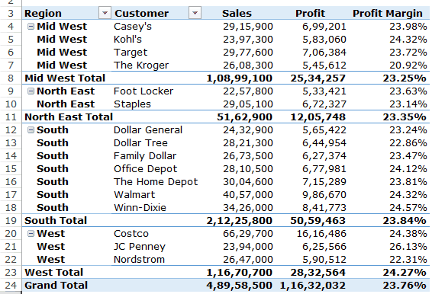

Pivot Table Example

With pivot tables, they are best used when you have a multitude of data that you would like to summarize and analyze. When they are used within different applications, pivot tables typically do not require many formulas to structure the data into a readable format. In organizing the table, you only need to drag drop into certain areas to gain better insight or change how it is grouped all together. Author Thierry Tremblay presents some common uses of the pivot tables:

Run automatic calculations on summed or counted values

Create percent of totals

Segment data by date, user or other variable and calculate totals

Organize data into columns and rows with automatic calculations that would otherwise be impossible with Excel

After seeing common uses of pivot tables, it is important to understand the advantages and disadvantages of use these tables to examine the data you are given at the time. In the application of Excel, a pivot table has the possibility of utilizing a SQL export for the data in the table. (Chief, 2017) When obtaining information from a spreadsheet or database, pivot tables make it easier to segment in different groups. A downside of using pivot tables is that they can be a time-consuming venture since the tool does not include calculation options in many instances. (Chief, 2017) Because of the restrictions of the calculations, some data may take much longer to perform calculations on or formulas will need to be inputted in order to obtain the desired output. A second disadvantage to pivot tables is that it takes to time to structure them to a point where they can be in a usable fashion. Even though it may be easy to understand how to work with the pivot table, applications typically do not provide a strong user experience. Once you understand the benefits and limitations of using pivot tables as a whole, you can then understand the best route in organizing your data and providing the best answers. (Chief, 2017)

In the end, pivot tables are a great tool for being able to summarize your data as a whole. My only experience with the tables are in Excel and in different business intelligence environments, and I can attest to its capabilities for allowing someone to explore more and gain a better understanding when they are presented with immense amounts of data. At the same time, with being able to customize how you group the data is my opinion my favorite part of these tables.

References:

Chief, E. in. (2017, December 5). 8 Advantages and Disadvantages of Pivot Tables. Retrieved April 21, 2020, from <https://connectusfund.org/8-advantages-and-disadvantages-of-pivot-tables>

Tremblay, T. (2019, February 14). Online Database Software. Retrieved April 21, 2020, from <https://www.kohezion.com/blog/what-is-a-pivot-table-examples-and-uses/>